## **Objectives**

* Explain React components
* Identify the differences between components and JavaScript functions
* Identify the types of components
* Explain class component
* Explain function component
* Define component constructor
* Define render() function

In this hands-on lab, you will learn how to:

* Create a function component
* Apply style to components
* Render a component

## **Prerequisites**

The following is required to complete this hands-on lab:

* Node.js
* NPM
* Visual Studio Code

## **Notes**

Estimated time to complete this lab: **30 minutes.**

Create a react app for Student Management Portal named scorecalculatorapp and create a function component named “CalculateScore” which will accept Name, School, Total and goal in order to calculate the average score of a student and display the same.

1. Create a React project named “scorecalculatorapp” type the following command in terminal of Visual studio:



1. Create a new folder under Src folder with the name “Components”. Add a new file named “CalculateScore.js”
2. Type the following code in CalculateScore.js

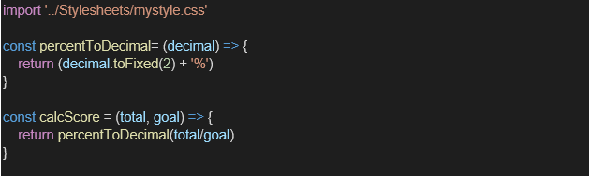

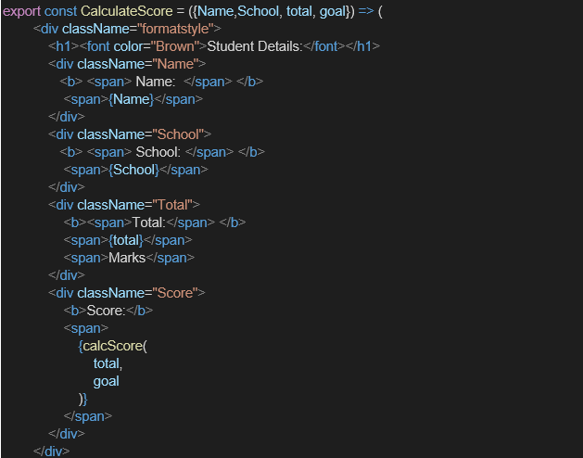

1. Create a Folder named Stylesheets and add a file named “mystyle.css” in order to add some styles to the components:

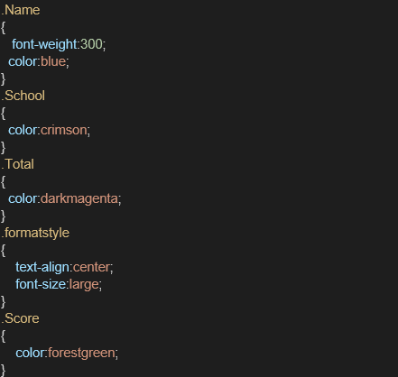

1. Edit the App.js to invoke the CalculateScore functional component as follows:

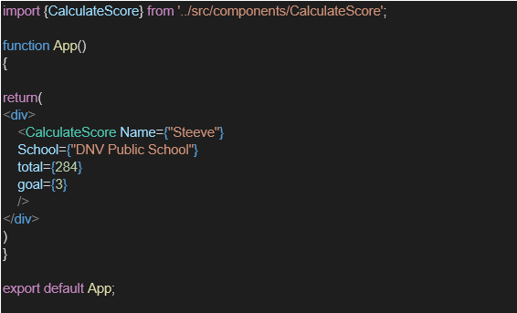

1. In command Prompt, navigate into scorecalculatorapp and execute the code by typing the following command:



1. Open browser and type “localhost:3000” in the address bar:

my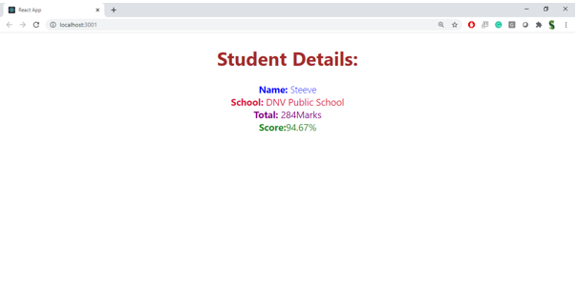

**mystyle.css**

. score-container {

  background-color: #f2f2f2;

  padding: 20px;

  margin: 20px auto;

  width: 300px;

  border-radius: 10px;

  text-align: left;

  font-family: Arial, sans-serif;

  box-shadow: 0 4px 8px rgba(88, 202, 17, 0.1);

}

.score-container h2 {

  color: #bd0a0a;

}

.score-container p {

  margin: 8px 0;

}

**App.css**

.App {

  text-align: center;

}

.App-logo {

  height: 40vmin;

  pointer-events: none;

}

@media (prefers-reduced-motion: no-preference) {

  .App-logo {

    animation: App-logo-spin infinite 20s linear;

  }

}

.App-header {

  background-color: #282c34;

  min-height: 100vh;

  display: flex;

  flex-direction: column;

  align-items: center;

  justify-content: center;

  font-size: calc(10px + 2vmin);

  color: white;

}

.App-link {

  color: #61dafb;

}

@keyframes App-logo-spin {

  from {

    transform: rotate(0deg);

  }

  to {

    transform: rotate(360deg);

  }

}

**App.js**

import React from 'react';

import './App.css';

import CalculateScore from './Components/CalculateScore';

function App() {

  return (

    <div className="App">

      <CalculateScore name="Sowmiya" school="RMK School" total={450} goal={5} />

    </div>

  );

}

export default App;

